Project Design Phase-II
Data Flow Diagram & User Stories

Date | 01 January 2026
Team ID | 4967
Project Name | Shopez
Maximum Marks | 4 Marks

Data Flow Diagrams:
A Data Flow Diagram (DFD) illustrates how data moves within the Shopez platform. It captures how users (customers and admin) interact with the system, how information flows between different components, and where the data is stored.
Example: DFD Level 0 (Industry Standard)

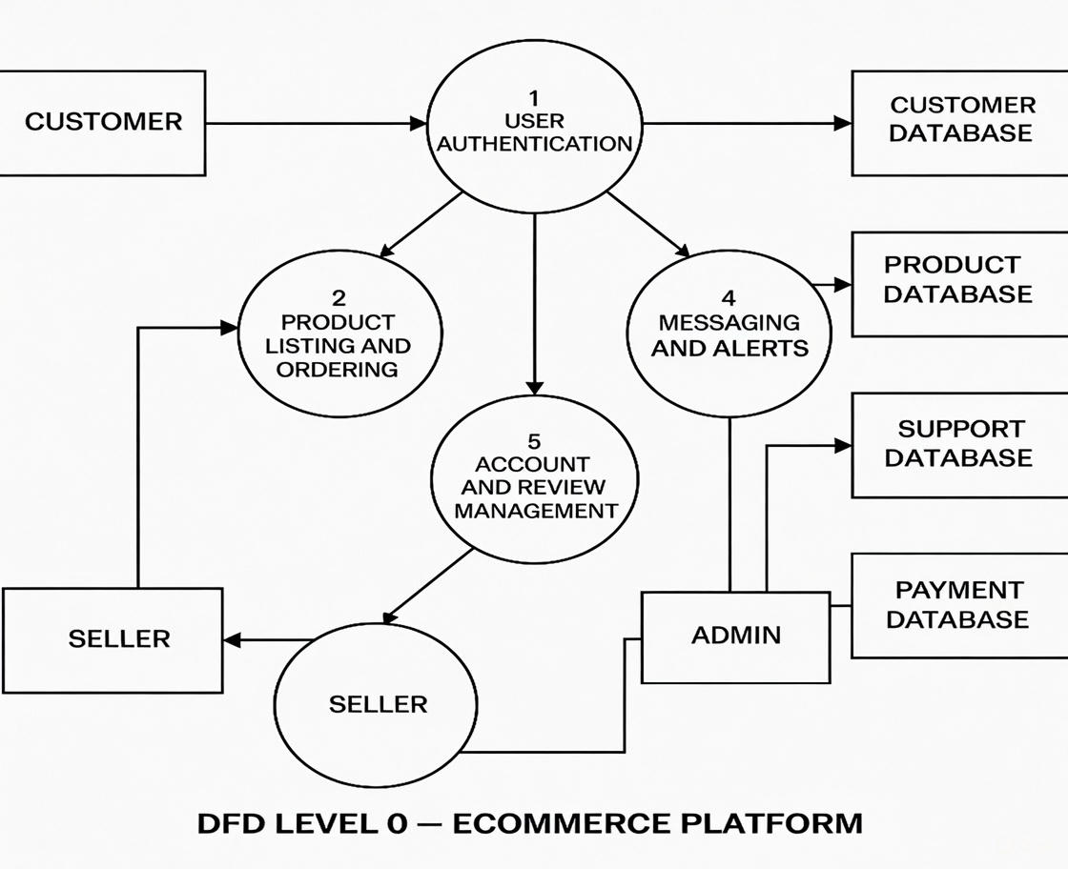

User Stories

User Story Table – Bookstore

User Type | Functional Requirement (Epic) | User Story / Task | Acceptance Criteria | Priority | Release
Customer |  | As a customer, I can browse all products on home page. | Products displayed with name, price, image, category. | High | Sprint-1
  Product Browsing
Customer |  | As a customer, I can search products by name/description. | Relevant results appear with count. | High | Sprint-1
  Product Search
Customer | Product Details |  | Full page with description, large image, price. | High | Sprint-1
  As a customer, I can view product details.
Customer | Shopping Cart | As a customer, I can add/remove/adjust quantity in cart. | Cart badge updates, total calculated. | High | Sprint-2
Customer | User Authentication | As a customer, I can register and login. | Successful login shows greeting. | High | Sprint-2
Admin | Product Management | As an admin, I can add, edit, or delete products. | Changes reflect immediately on site. | High | Sprint-2
Admin | Admin Panel Access | As an admin, I can access admin panel. | Only admin@example.com sees /admin route. | High | Sprint-2

